VPN Traffic

🔐 What Is VPN Traffic?
# Source: AI Source: Provided by: [Data Path: Persons Table -> ID Column: 1, Name_En Column: Motasem Essam] -> From: [ChatGPT] on [12/18/2025]
VPN traffic is data that is transmitted over a Virtual Private Network (VPN) — a secure, encrypted connection between your device and a remote VPN server. This traffic is encapsulated and encrypted, allowing users to browse privately, secure sensitive data, and bypass geo-restrictions.

🧠 Simple Definition:
# Source: AI Source: Provided by: [Data Path: Persons Table -> ID Column: 1, Name_En Column: Motasem Essam] -> From: [ChatGPT] on [12/18/2025]
VPN traffic is regular internet traffic (e.g., web browsing, voice, video) that has been encrypted and tunneled through a VPN server to protect privacy and security.

📡 How VPN Traffic Works:
# Source: AI Source: Provided by: [Data Path: Persons Table -> ID Column: 1, Name_En Column: Motasem Essam] -> From: [ChatGPT] on [12/18/2025]
- You connect to a VPN client on your device.
- The client establishes a secure tunnel to a VPN server.
- All your traffic (e.g., websites, apps, email) is encrypted and routed through this tunnel.
- The VPN server then forwards your request to the destination (e.g., a website).

You → VPN Client → Encrypted Tunnel → VPN Server → Internet

🔐 Key Features of VPN Traffic
# Source: AI Source: Provided by: [Data Path: Persons Table -> ID Column: 1, Name_En Column: Motasem Essam] -> From: [ChatGPT] on [12/18/2025]
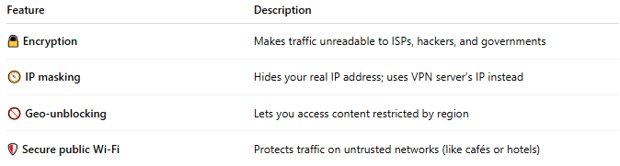
Feature | Description
🔒 Encryption | Makes traffic unreadable to ISPs, hackers, and governments
🧭 IP masking | Hides your real IP address; uses VPN server’s IP instead
🚫 Geo-unblocking | Lets you access content restricted by region
🛡 Secure public Wi-Fi | Protects traffic on untrusted networks (like cafés or hotels)

🧰 Common VPN Protocols (Tunnel Types)
# Source: AI Source: Provided by: [Data Path: Persons Table -> ID Column: 1, Name_En Column: Motasem Essam] -> From: [ChatGPT] on [12/18/2025]
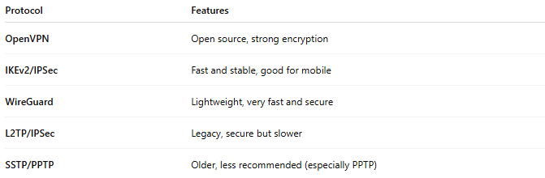
Protocol | Features
OpenVPN | Open source, strong encryption
IKEv2/IPSec | Fast and stable, good for mobile
WireGuard | Lightweight, very fast and secure
L2TP/IPSec | Legacy, secure but slower
SSTP/PPTP | Older, less recommended (especially PPTP)

📦 What’s Inside VPN Traffic?
# Source: AI Source: Provided by: [Data Path: Persons Table -> ID Column: 1, Name_En Column: Motasem Essam] -> From: [ChatGPT] on [12/18/2025]
Even though it may carry regular HTTP or voice traffic, VPN traffic looks like encrypted binary data on the outside:
- Payload: Your actual data (e.g., website, voice, video)
- Encryption layer: Prevents inspection
- Tunnel header: For routing the data through the VPN

🚦 VPN Traffic vs Normal Traffic
# Source: AI Source: Provided by: [Data Path: Persons Table -> ID Column: 1, Name_En Column: Motasem Essam] -> From: [ChatGPT] on [12/18/2025]
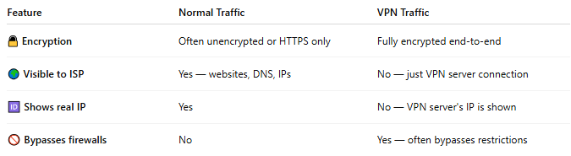
Feature | Normal Traffic | VPN Traffic
🔓 Encryption | Often unencrypted or HTTPS only | Fully encrypted end-to-end
🌍 Visible to ISP | Yes — websites, DNS, IPs | No — just VPN server connection
🆔 Shows real IP | Yes | No — VPN server's IP is shown
🚫 Bypasses firewalls | No | Yes — often bypasses restrictions

📌 Summary
# Source: AI Source: Provided by: [Data Path: Persons Table -> ID Column: 1, Name_En Column: Motasem Essam] -> From: [ChatGPT] on [12/18/2025]
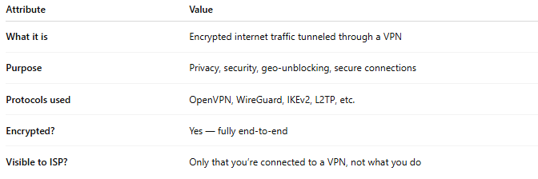
Attribute | Value
What it is | Encrypted internet traffic tunneled through a VPN
Purpose | Privacy, security, geo-unblocking, secure connections
Protocols used | OpenVPN, WireGuard, IKEv2, L2TP, etc.
Encrypted? | Yes — fully end-to-end
Visible to ISP? | Only that you’re connected to a VPN, not what you do

